MOUNT TIYI COLLEGE
WOKHA, NAGALAND

ALUMNI FEEDBACK REPORT 2025-26

The Alumni Feedback Analysis Report has been prepared on the basis of responses received from the Alumni. The responses were gathered online using Google form in the month of July 2025. Altogether ninety-one (91) alumni participated in the survey out of which 48 were male respondents and 43 female. The highest percentage of respondents (17.61%) came from the 2022 graduates. The alumni feedback came from diverse age groups, the oldest respondent being 61 years of age while the youngest respondent is 20 years old.

Provided below are the feedbacks received from the alumni. Comments and suggestions made by the respondents are also provided in the report.
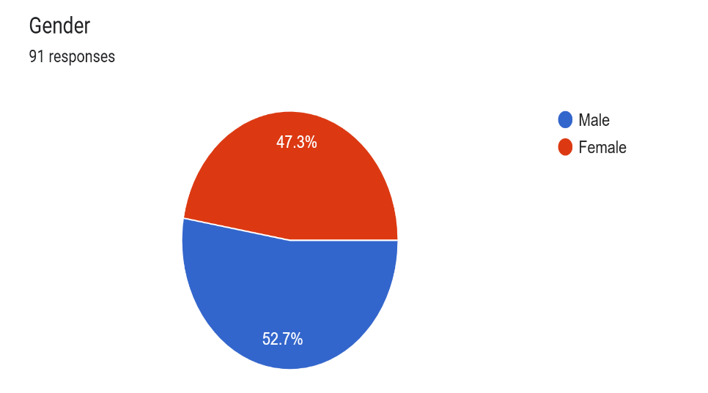
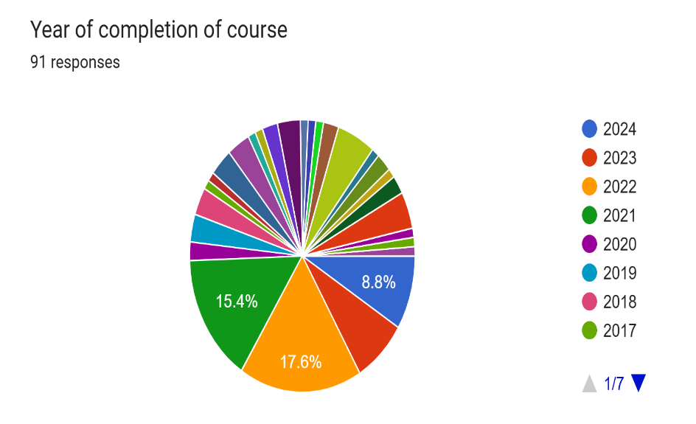

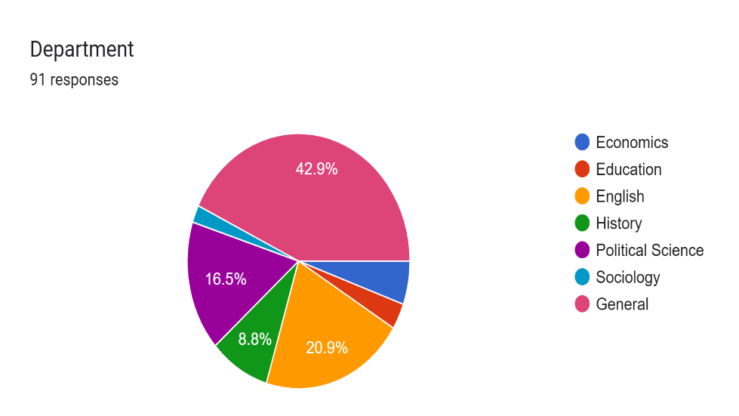

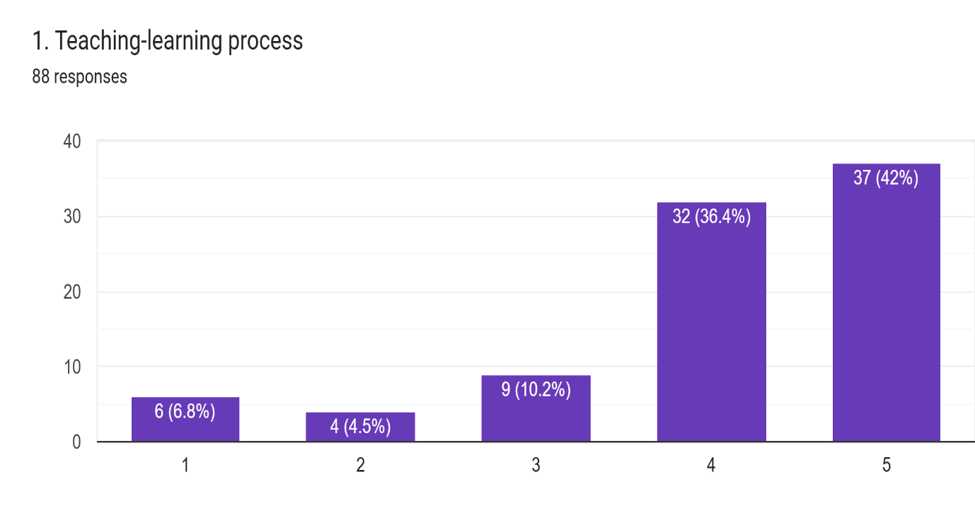

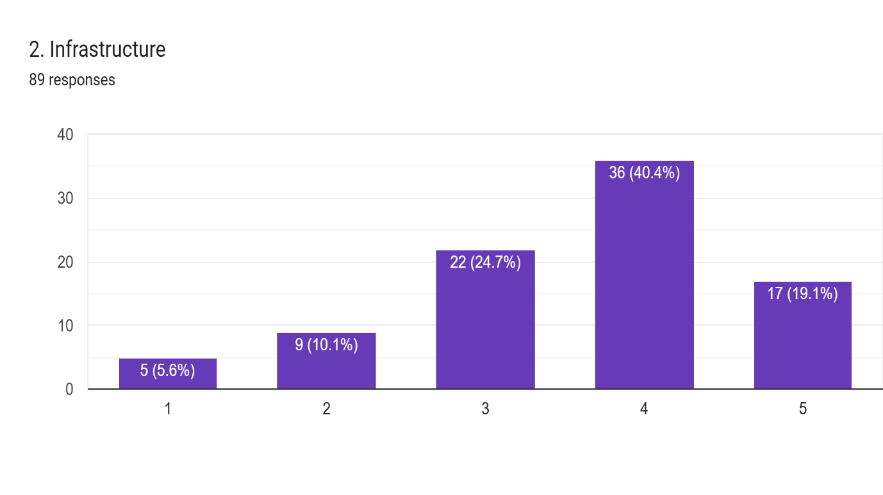

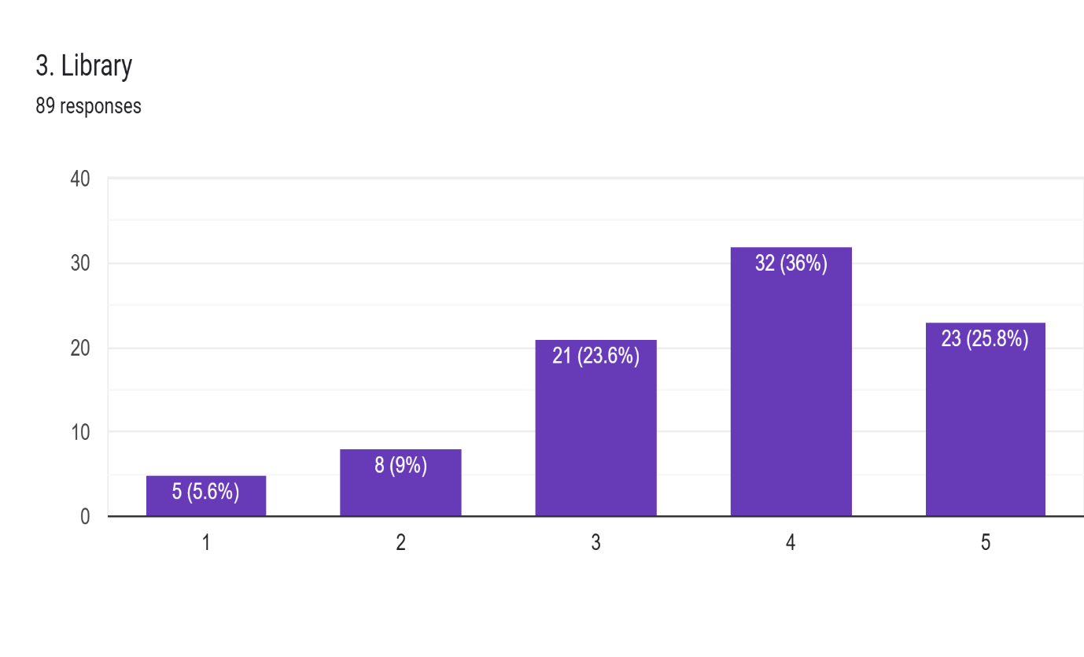

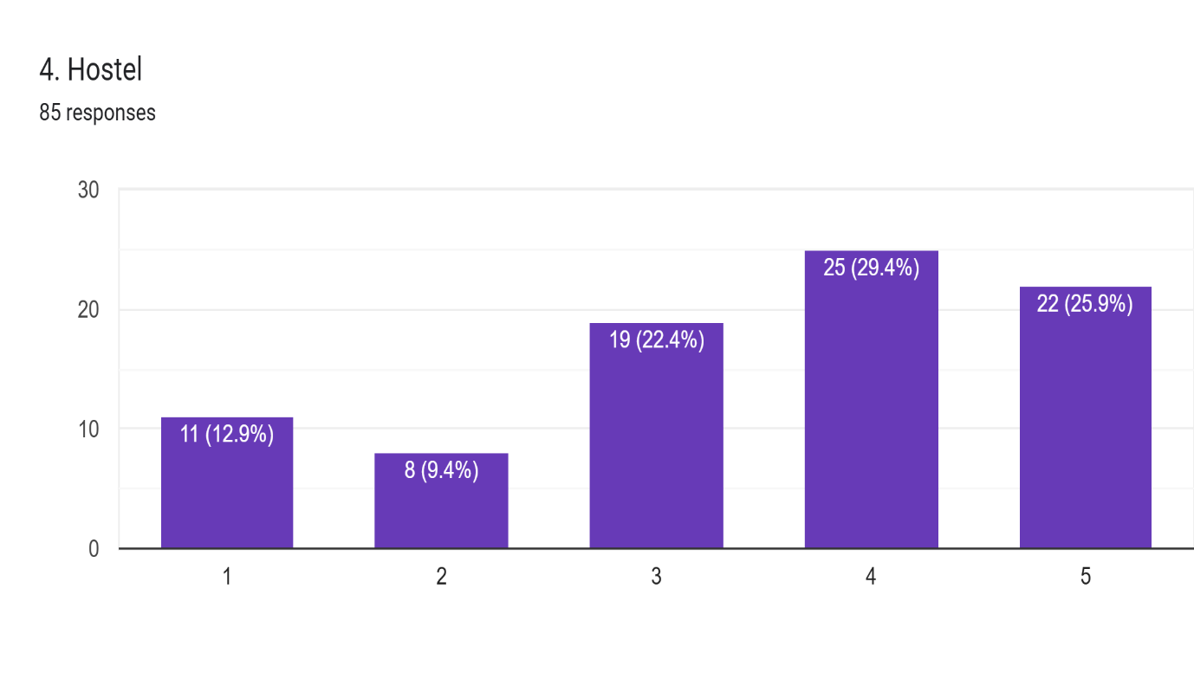

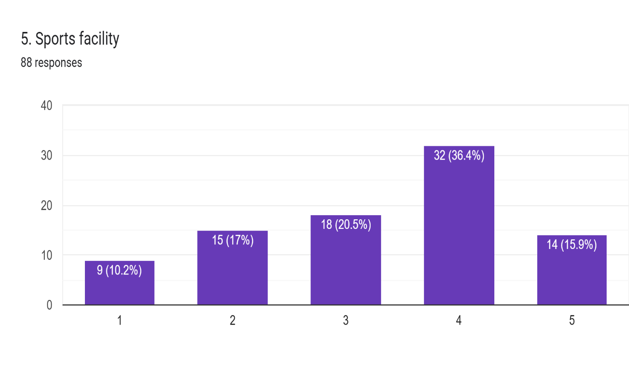

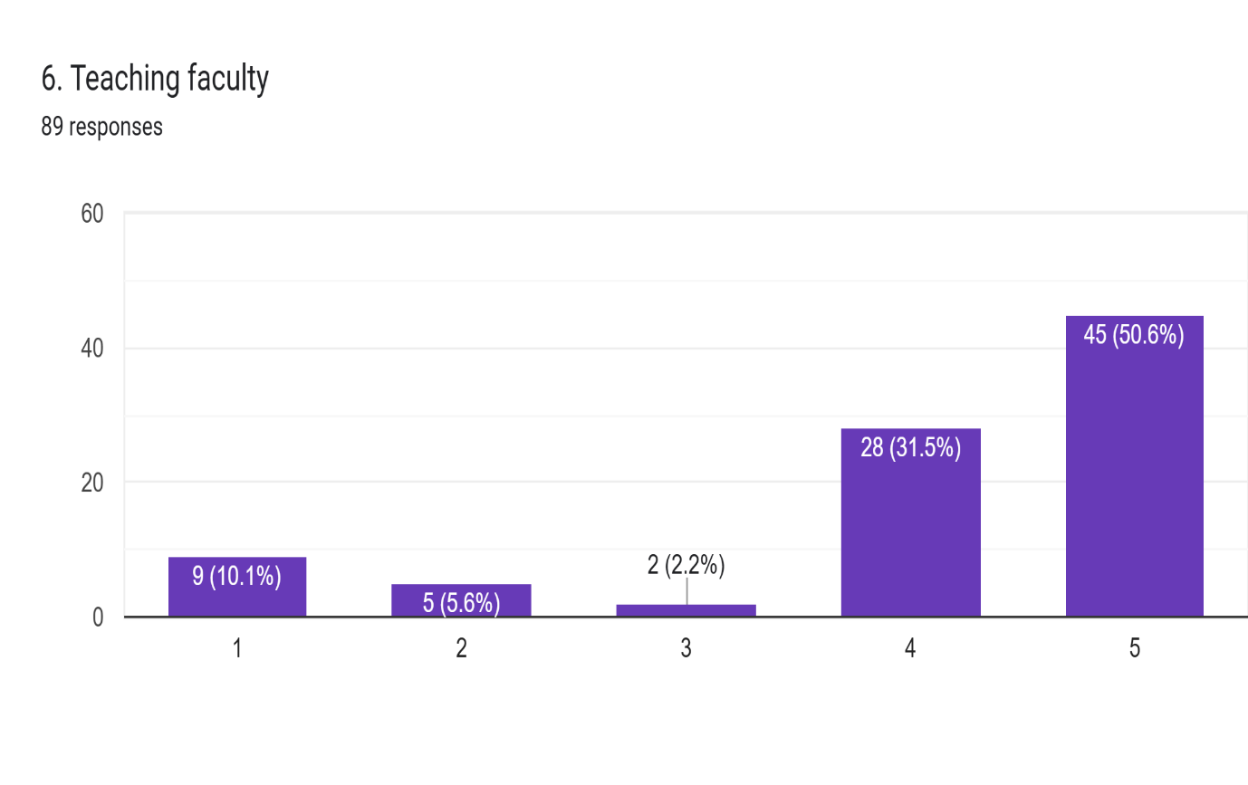

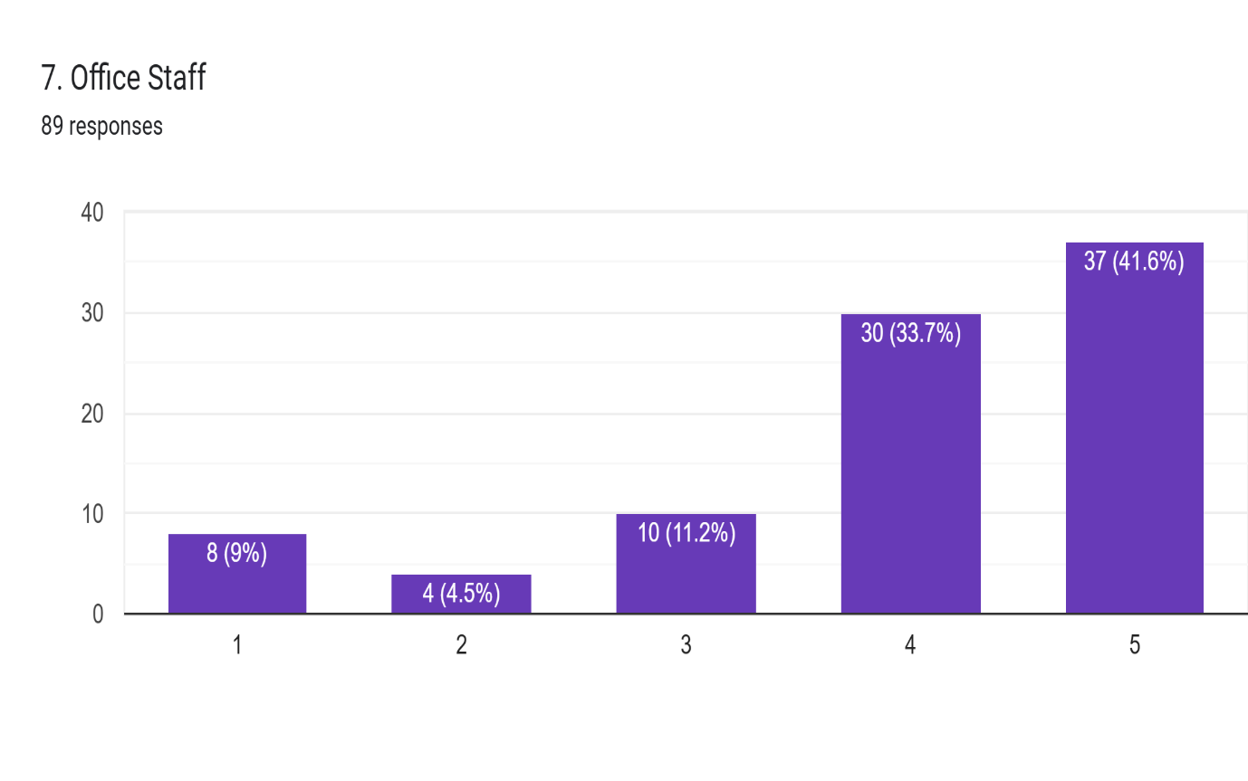

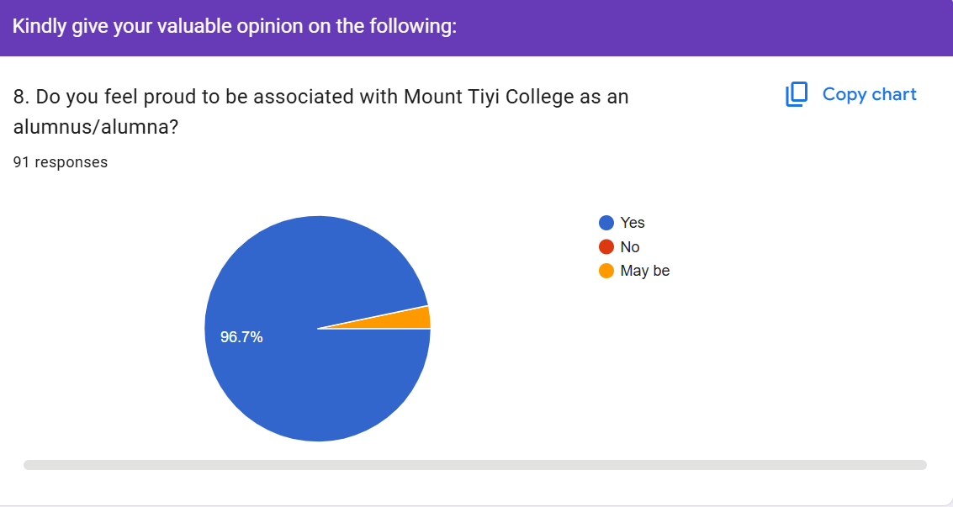

9. Suggestions for Alumni Association activities
61 responses
- Keep up your good work
- Mentorship programs Guest lecturers and workshops Scholarship or financial support
- Need to do more awareness on civic sense & responsibility cultivation, career guidance, conduct extra curricular activities etc..
- Cultural Festival or Heritage Day
- More get together meetings
- I feel that many of our alumni are still not part of this group, and because of that, they miss out on meetings, programmes, and other activities. It would be really good if we could make more effort to include everyone, so that all alumni feel connected and involved. Maybe we can try to reach out to those who are not yet in the group through classmates or friends, and gradually build a complete alumni network. Also, for any meetings or programmes, if we can inform early and keep them open for all, including those who are outside the town, it will make participation easier. We can also think about organising more engaging activities like reunions, mentorship for juniors, career guidance sessions, or even small community programmes. This will help strengthen our bond and make the association more active and meaningful. It would also be helpful to have regular updates here so everyone stays informed, and we can always take suggestions from members to improve further. Also, if we can have a small media team for the alumni to handle updates, posts, and coverage of events, I would be glad to be part of it and contribute. Just sharing this with the hope that we can make our Alumni Association more inclusive, active, and connected. Thank you.
- More engagements
- Meeting is required to get connected
- Fundraising for any college toppers.
- Carrier counciling
- To promote cultural activities and enhance more on sports weeks
- Should be more vocal and active regarding the college
- Literary competition, Cultural show..etc
- Social and community service
- Unity should always be along us.
- Carrer guidance oriented programme.for students
- If a form is provided to everyone batch after graduation or end semester exam so that everyone alumni is included with any missout.
- Work for the upliftment of the College
- Have more coordination.
- Annual Alumni meet
- Workshop on soft skills and Digital skills
- Efforts to make the institute the best among all colleges, introduce science and commerce streams as well
- Organize alumni meets and reunion
- Sports+Picnic Annually
- Alumni meet
- More role from govt side .
- Improvement for the college both academic and non academic
- None.
- Social and community service, mentorship programme
- Organise social activities annually
- To host educational programs and create opportunity
- Better attendance
- During my time at the college (2019–2022 batch), there were limited opportunities in areas like academics, sports, and skill development. As an alumnus, I would strongly suggest that the Alumni Association take a more active role in strengthening these aspects. Organizing workshops, mentorship programs, sports events, and career-oriented skill sessions could greatly enhance student engagement and overall growth. The college environment felt quite easy-going, but with more structured and meaningful activities, students can be more motivated and involved in their learning journey. The goal should be to create a more dynamic and inspiring atmosphere where students not only study but also develop practical skills and passion for what they do.
- Career Guidance.
- More activeness
- We all should be support to our association
- Yearly get together
- To organize at least 2-3 more activities / events in addition to the regular alumni programs and activities.
- To be involved in college activities
- Should include meetings, informal gatherings.
- Better communication for everyone
- No
- To organize job oriented activity for students time to time
- Support both physical and educational development through active participation.
- Helping the upcoming students in skills on income
- Add of new papers like Journalism and Mass communication
- To take up Career counselling activities on regular basis.
- Alumni meet,Alumni achievement awards
- Engaging in social activities and conducting career counseling and imparting skill development guidance
- Organize professional networking events, career panels, and industry-specific mentorship programs to provide tangible value to graduates. Complement these with engaging social activities like reunions, trivia nights, and family-friendly campus days to foster nostalgia and community connections.
- A meet-up every year
- Career Counseling
- More activities and participation
- To organize carrier counselling based on skills development
- Triennial meet would be appreciated
- Honesty
- Skill Development Workshops ,communication, hospitality, entrepreneurship
- Alumni Association annual meet in a calander year
- 10. What efforts should the college take to integrate its alumni in further enhancing the overall quality of the Institution? 51 responses
- Start mentorship program for students guidance. Encourage alumni to fund scholarship and resources
- Keeping in constant touch with the Alumni members ,seek straight from the heart advice
- Job advertisement etc
- Involvement in necessary programs and services like how it has been going
- To effectively integrate alumni in enhancing the overall quality of the institution, the college can take several proactive steps. Firstly, the college should build and maintain a strong and updated alumni database. Many alumni remain disconnected simply due to lack of communication, so creating an organised system to track and reach out to them is essential. Secondly, the institution can actively involve alumni in academic and developmental activities. Alumni can be invited for guest lectures, workshops, and career guidance sessions, where they can share their real-world experience and insights with current students. The college can also establish structured mentorship programmes, connecting alumni with students for guidance in academics, career planning, and skill development. This will create a meaningful bridge between past and present students. Regular alumni meets, seminars, and networking events should be organised to strengthen relationships and encourage continued engagement. These gatherings can also serve as platforms for discussion on institutional growth and improvement. Additionally, the college can encourage alumni contributions towards infrastructure development, scholarships, internships, and placement opportunities. Alumni working in different sectors can help open doors for students. Creating an official alumni association with a clear structure and dedicated roles will also ensure better coordination and sustained activities. A media or communication team can help in maintaining visibility, sharing updates, and highlighting achievements. Importantly, the college should recognise and appreciate the contributions and achievements of its alumni. This not only builds goodwill but also motivates others to stay connected and contribute. Lastly, feedback from alumni should be regularly sought and valued. Their perspectives can help the institution improve its academic quality, relevance, and overall functioning. Through these efforts, the college can build a strong alumni network that actively contributes to the institution’s growth, reputation, and quality
- College should take Suggestions and Ideas from Alumni.
- To stay in touch with us
- It would be better if the college take up more programs where the alumni can contribute and take part
- Have a good interaction n co-relation.
- In mentorship, academic and career support
- Proper Sports facility
- The institute authority should coordinate or take into confidence ot the Alumni association participation positively for shaping the up coming students
- Work together
- The college governing body has to put a good amont of effort in taking the alumni association into account. Apart from the academic activities so much more can be done, as educating people coming from plethora of backgrounds have to be done depending one their IQ, desires, talents, weaknesses etc
- Same as point 11 mentioned below
- Involving successful alumni from all walks in Institutional activities can be considered in enhancing the quality of the college.
- Frequent visit to the institute, interact with students, teachers and parents.
- Invite alumni for seminars and mentoring
- Invite alumni as guest lecturers / visiting faculty
- More regularly integrate.
- Reaching out through positive approach
- Collective contribution for the welfare of the upcoming student's.
- Networking and meetup
- The college and alumni association should work hand to hand and take the college to new heights!
- Yearly plan program with the present students along with the Alumni
- To enhance the overall quality of the institution, the college should actively involve its alumni in meaningful and structured ways. Alumni can play a key role by sharing their real-world experiences, guiding students, and contributing to institutional development. The college can organize regular alumni–student interaction sessions, mentorship programs, and career guidance workshops where alumni provide insights into different industries. Creating a strong alumni network or platform will help maintain continuous engagement and communication. Additionally, alumni can be invited to contribute to curriculum improvement by sharing industry-relevant skills and expectations. They can also support internships, placements, and skill development initiatives. Encouraging alumni to participate in sports events, cultural programs, and institutional planning can further strengthen the connection. Overall, building a strong alumni relationship will help create a more dynamic, skill-oriented, and future-ready learning environment.
- Curriculum development, participation of alumni in decision-making to improve academic and institutional standard.
- Constant contact: Include them in the college governing body so that they are also aware of the situations prevailing in the college. This will help to them gather first hand information and assist the college accordingly in their own capacity. - they may also be included in planning / development committees to mobilze resources through their alumni network.
- To presser the college authority to give good quality education
- Inclusive program for every alumni once in a while
- No
- To work hand in hand with the alumni for the students carriers ( job, business etc)
- Need to have strong bonding through connectivity and involvement of the association when needs arise.
- Importance in sports and activities
- Infrastructure and quality education
- To regularly invite the members to interact and participate in the college activities and programs.
- Invite alumni to share their professional experiences through guests lectures, seminars etc which helps current students alot..
- Quaterly meet up with improve ideas sharing and implementing on ground
- To enhance institutional quality, the college should establish a robust Alumni Connect Cell and maintain an updated database to foster a lifelong, two-way relationship. Key efforts include initiating early engagement before graduation to cultivate affinity, implementing mentorship programs that pair experienced graduates with current students for career advice, and involving alumni in curriculum development to align courses with current industry demands. Institutions should leverage alumni expertise through guest lectures, invite them to serve on advisory boards or governing bodies to shape strategic direction, and utilize digital platforms for targeted, interactive communication, ensuring their valuable insights directly improve student employability and the overall academic experience.
- Invite alumni to lead sessions on emerging industry trends, bridging the gap between classroom theory and professional practice.
- Involve alumnis with college activities once in a year,
- College should initiate more programs that will involve active participation of alumni
- Cooperation
- Encouraging them to participate in college activities
- Appointing a senior faculty as alumni coordinator
- Programing
- Use alumni network for internships and job placements
- Enhancing network and Cooperation

- Suggestions for further improvement of the institution
54 responses
- Update curriculum according to current trend. Provide digital learning process.
- As a teenager in college I was too shy and would hardly ever ask about lessons and what I thought was that would there be a professor/lecturer who would have been really friendly (to talk,share & speak to) i surely would have done better.. cutting it short.. student friendly educators would surely bring positive change in all aspects.
- Need improvement for better results.
- Water facility should be initiated
- One key suggestion for further improvement of the institution would be to focus on creating a more inclusive and engaging environment by strengthening communication between the administration, students, and alumni. By introducing more skill-based and career-oriented programmes, along with regular workshops and mentorship opportunities, the institution can better prepare students for real-world challenges. Additionally, encouraging active alumni involvement, improving infrastructure, and regularly seeking feedback from students and graduates can help ensure continuous growth and overall enhancement of the institution’s quality.
- Smart classrooms and better learning resources
- Effective Strategies
- Compound
- Apart from studies it would be better if the institutions also focus on other co curricular activities like skill development of the students
- Better infrastructure for cocurricular activities.
- Upgrade infrastructure and facilities
- Hostel, sports and canteen
- Being the only Govt college in the district affordable for for all sections of students, the efforts and dedication of the administration and teaching faculties should.be enhanced as is seen in the recent years for better results
- The college should focus more on all round development of the students with various activities and apportunities
- All satisfactory
- The properties of the institution should be free from all sorts of obligations; especially the land owners ties.
- 11 and 12 ,i.e Higher secondary classes to be brought back for higher enrollment and wider participation of the institution at the state and convenience of the General public
- Hoping to witness, Integrating ICT tools, like smart classes and Digital resources.
- Developmental activities.
- Enhance teaching method with practical learning
- Regular curriculum revision aligned with industry and competitive exams
- More development
- Introduce science stream.
- Campus upgradation
- Promoting Science Stream in the College.
- Career and skill development
- The college lacks infrastructure, to be precise, classroom fans, white/black boards, washrooms and toilets, sports facilities, outdoor activities and events, teacher-student relationship/interaction, etc.
- Quality time with the students and faculty
- Just as mentioned above.
- Improvement of infrastructure,digital facilities and enhance teaching methods with practical learning, etc.
- More infrastructure
- To promote mother tongue
- To introduce more honours paper/ subject and skill based courses. Upgrade sports infrastructures
- To be improve some modern facilities
- No suggestion.
- Better administration
- Ensure quality infrastructure and overall administration of the institution.
- Better campus environment
- To invite young in-service officers to guide the students for future competitive exams and to invite business man in all fields to educate them before they face the real world
- Opening of science stream in the college,good road connectivity.
- Expansion of the department’s and classrooms
- Good library ,and more of media exposure to increase the number of students
- As stated at para 10 above.
- Strengthening academic standard, improve infrastructure, more career guidance program,workshop , encourage extra curricular activities like sports, cultural etc
- The institution should include skill development training for future life sustainability
- To improve the college experience, institutions should focus on updating the curriculum to include more practical, project-based learning rather than just exams. Increasing the use of technology—such as high-speed Wi-Fi across campus and interactive smart classrooms—will make learning more engaging.
- Expand access to digital journals, e-books, and online databases for research.
- Upliftment of college infrastructures..
- Work hard
- Focusing on quality education and also providing its students with carrier counselling
- Integrity by the institution staff
- Scopes
- Skill based learning

