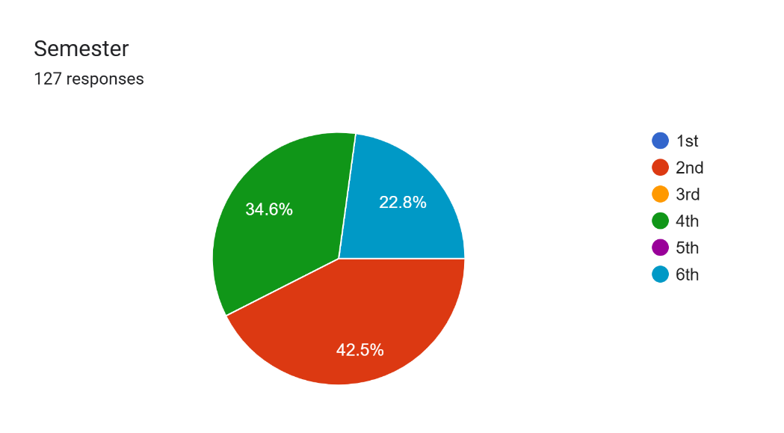
STUDENTS SATISFACTION SURVEY
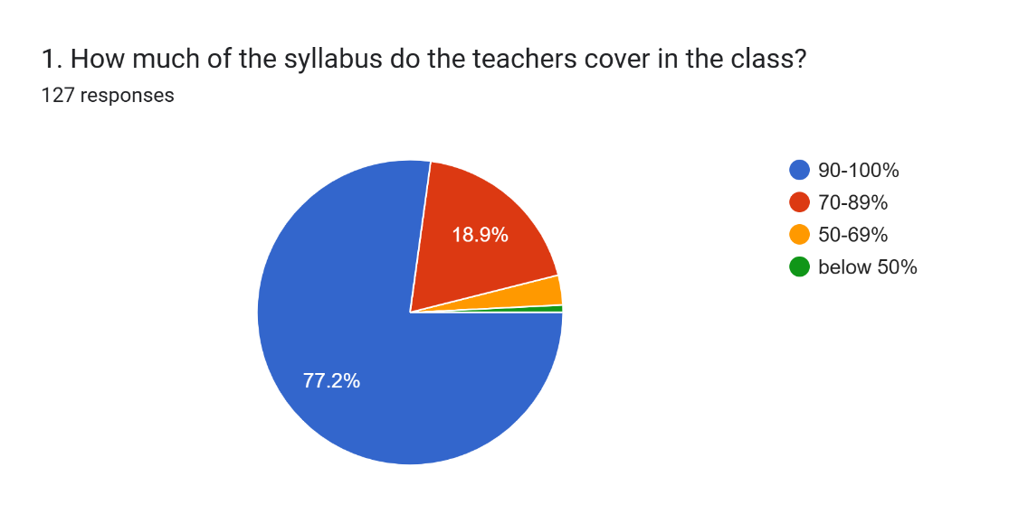
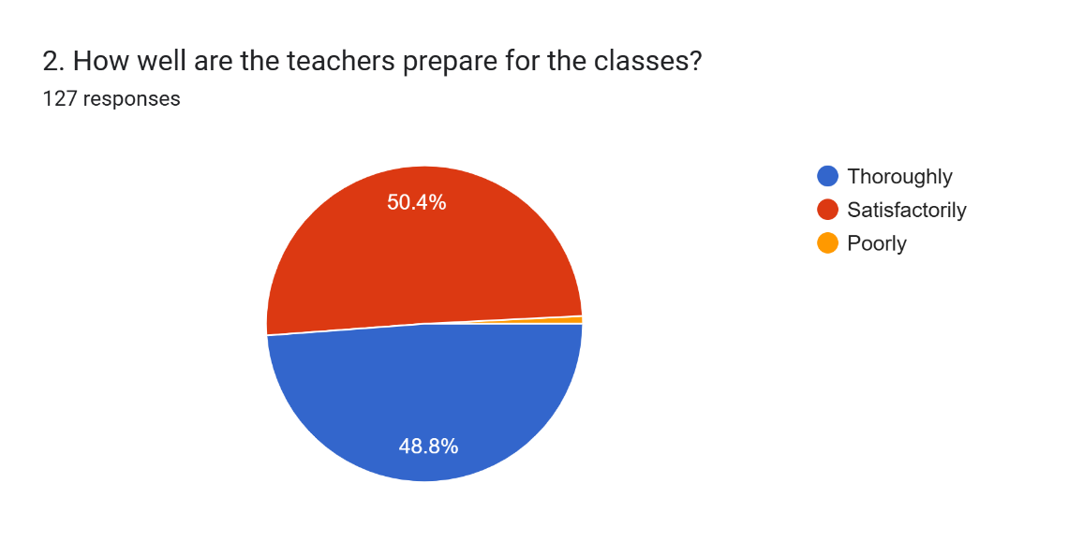
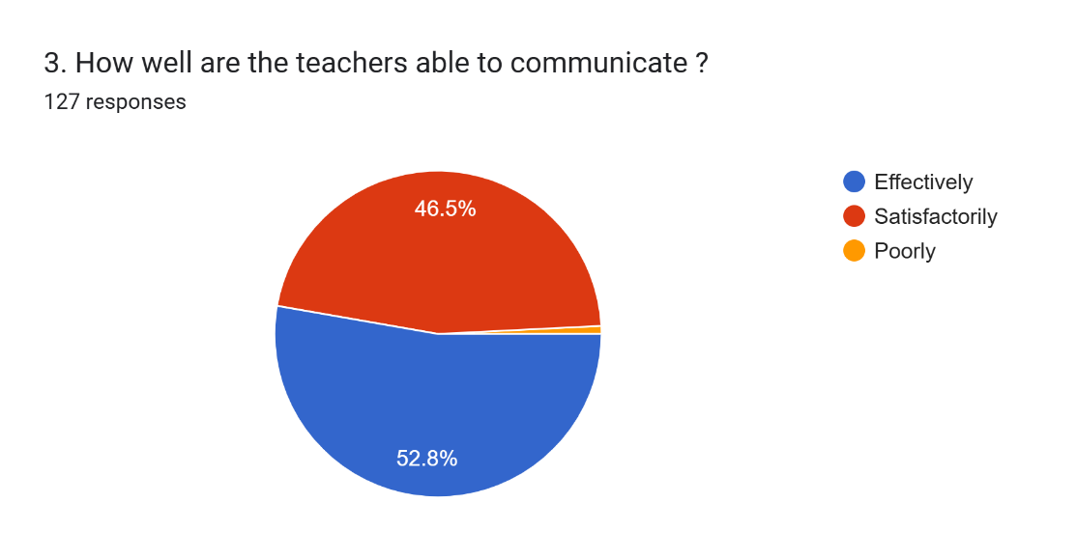
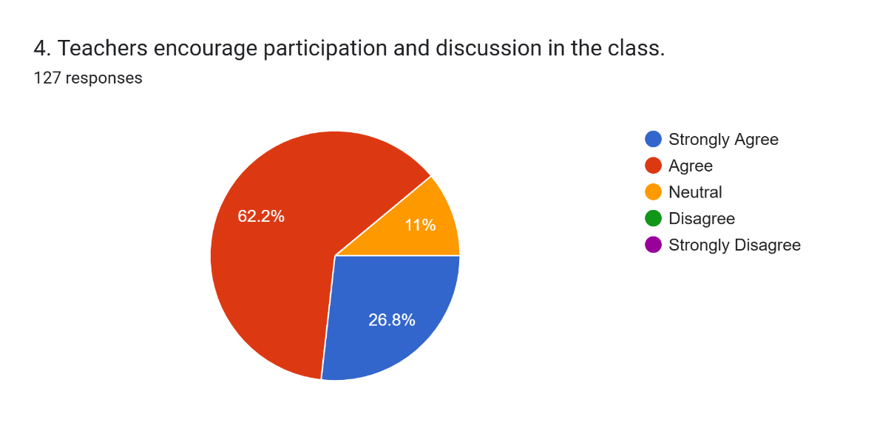
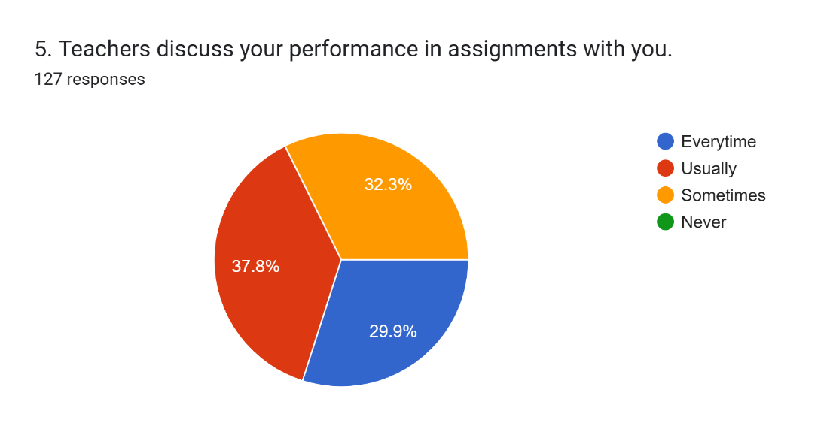
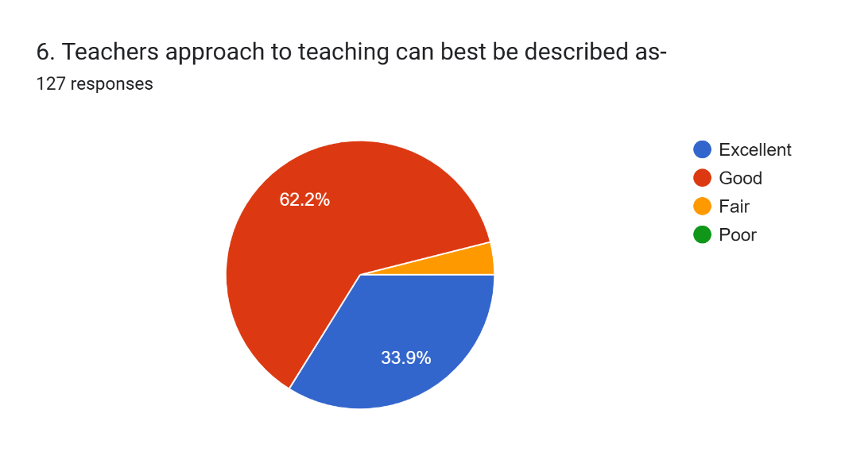
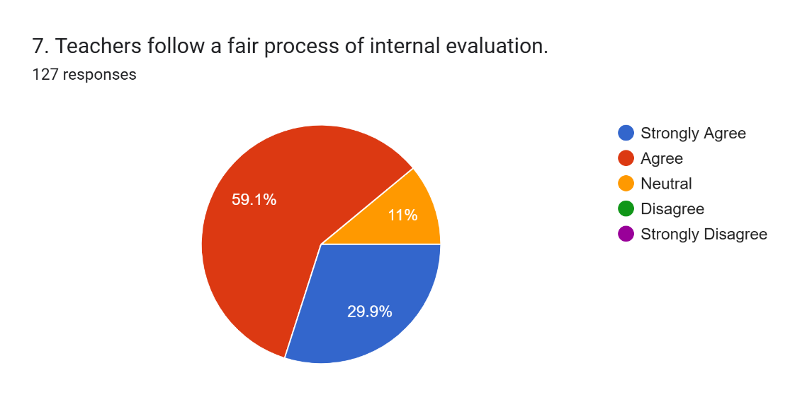
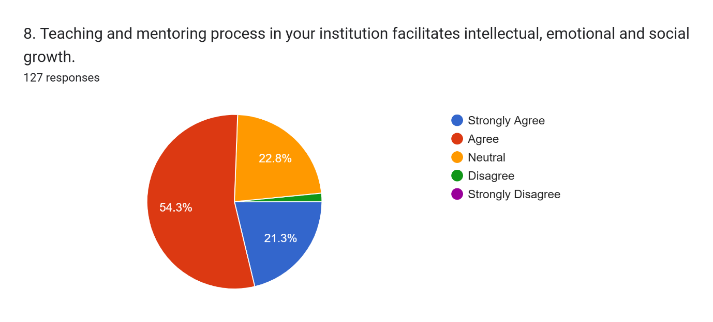
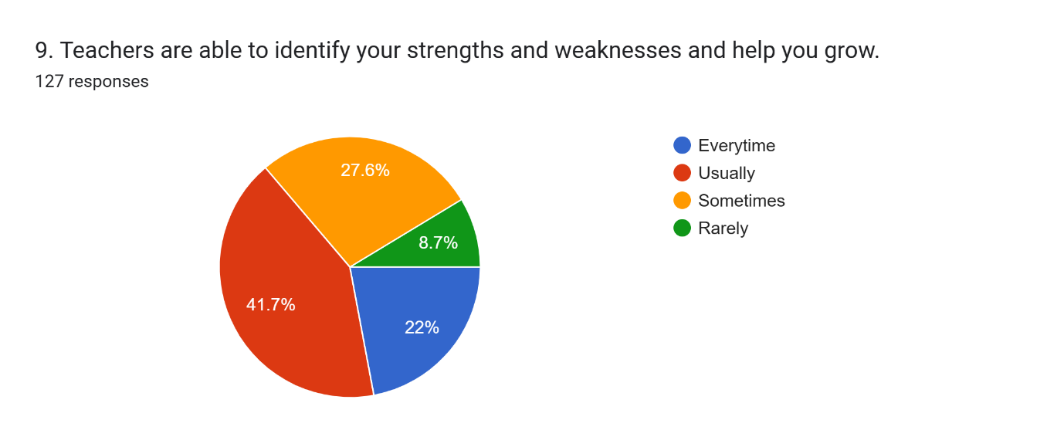
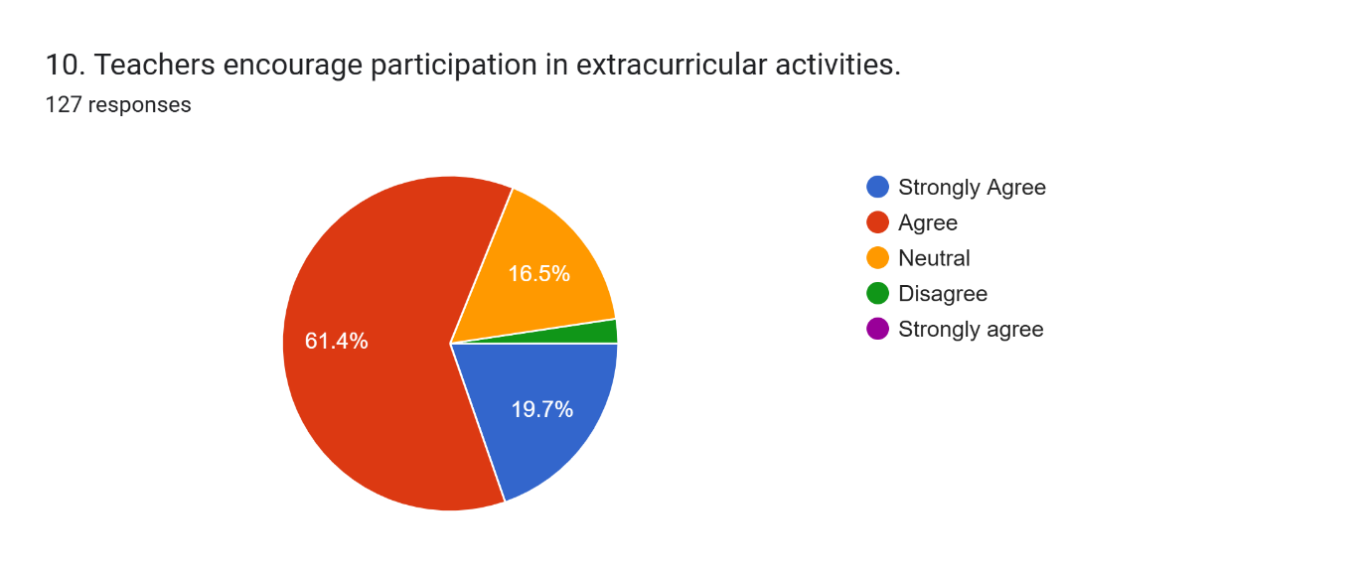
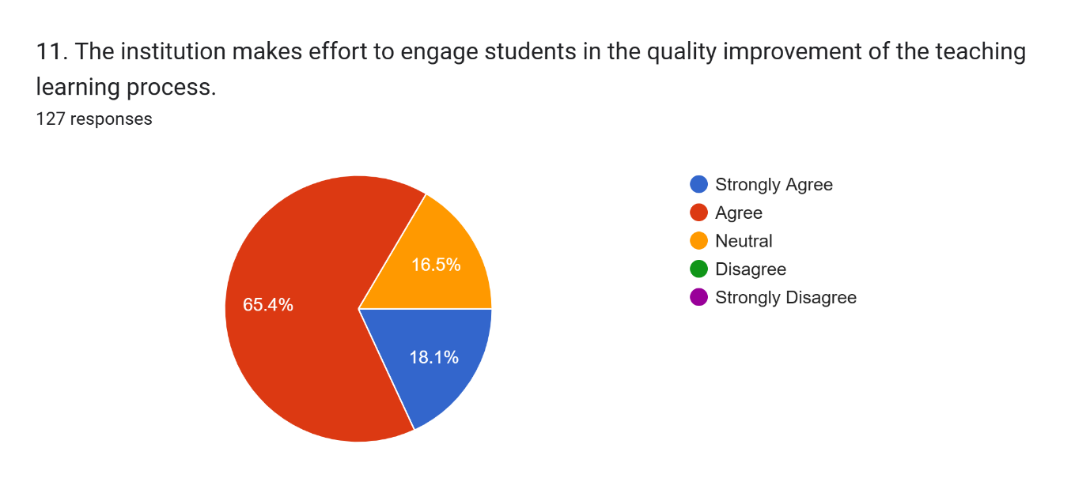
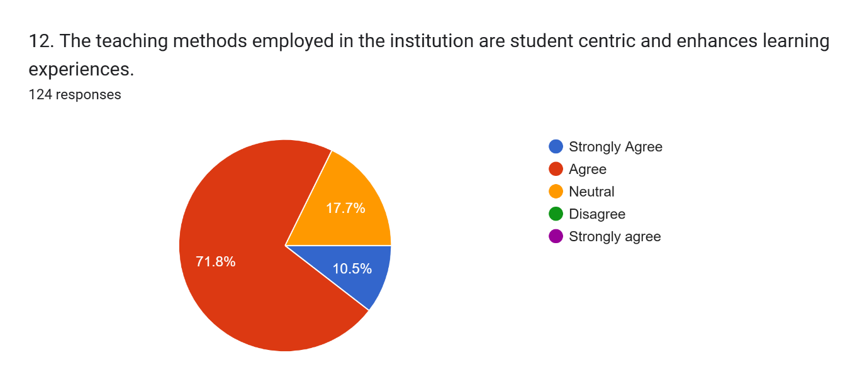
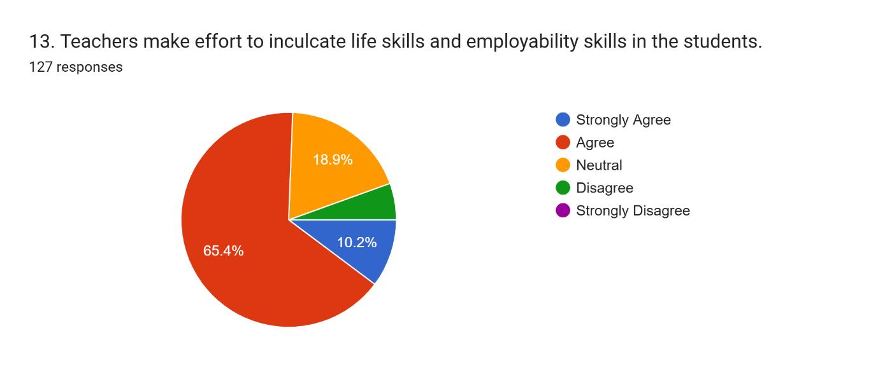
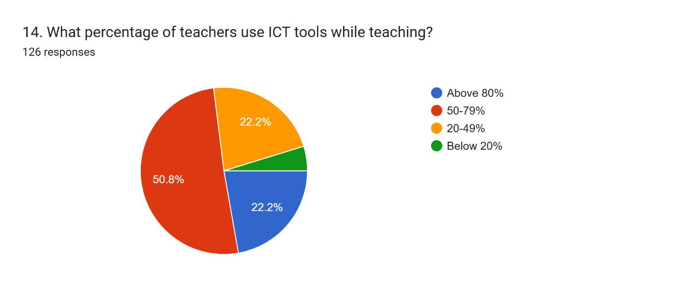
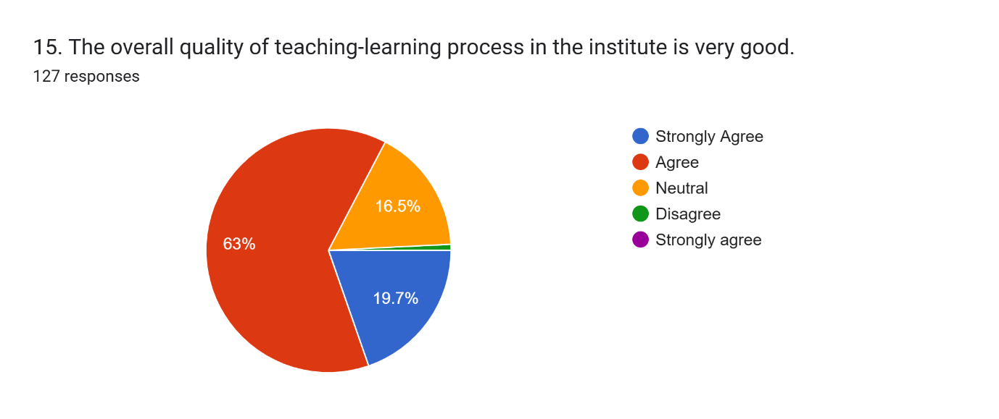
16. Give suggestions to improve the overall quality of teaching-learning experience in your institute.53 responses
- None
- Good
- Infrastructure and development
- Grow together
- Give more attention to the students
- “One suggestion to improve the overall teaching-learning experience in the institute is to ensure equal opportunities for all students. Teachers should encourage participation by asking questions to everyone equally, rather than focusing only on a few particular students. Similarly, in college activities and functions, opportunities should be given to all students instead of repeatedly selecting only the same high-performing or outspoken students. Proper information about activities should be shared with everyone so that interested students can come forward on their own. This will help average students build confidence, improve their communication skills, and prepare better for their future. Academic teaching is important, but creating a fair and inclusive environment for every student is equally important so that no student feels neglected or left behind.”
- Use more practical and interactive teaching methods and increase use of ICT tools like smart boards and presentations.
- To improve the overall quality of teaching- learning experience in my Institute, I would suggest the student - centered learning; encourage group discussion, project, and practical activities.
- Implement active learning strategies
- GOOD
- Give more attention to the students capacity and abilities
- To improve the teaching-learning experience, teachers should use digital tools, give timely feedback on assignments so, we can improve our performance and clear doubts effectively.
- Need to improve better environment
- The college needs improvement in basic facilities, proper classrooms, learning resources and study materials should be provided. Teacher should also give notes and guidance regularly to support students learning
- Provide while equipped classroom libraries, laboratories, and a comfortable learning environment good facilities directly support better learning
- Improve college infrastructure and encourage more co-curricular activities
- Put some more effort on extra curricular activities.
- All okay
- More extracurricular activities
- Teacher should understand individual learning needs
- Positive classroom environment....
- everything is good
- Enhance teaching methods, provide better infrastructure, and encourage interactive learning with regular feedback.
- For now it's all good
- There should be more co-curricular activities in the college like regular sports, cultural programs, debates, seminars, and fitness sessions alongside academic studies. These activities will help us to improve our physical health, teamwork, leadership skills, confidence, and practical knowledge. It will also create a balanced environment where the students can grow both mentally and physically, leading to better overall development.
- Teachers should move beyond only lecture-based teaching and use interactive methods like discussions, group work, presentations, and case studies. This makes classes more engaging and helps students understand concepts better.
- To maintain extracurricular activities in order to help the students grow physically and mentally
- Introduction of new and innovative teaching methods like, projection, trips, etc etc
- No comments
- Strong bonding with teacher's and students.
- Provide regular feedback and doubt-clearing sessions for students
- There is a minimal use of digital tools in teaching -learning process in our institute,like in every classroom there is a projector and those are not meant for some kind of decoration, make better use of it so that it make education more engaging and effective.
- Updated study materials and regular interaction between the faculty will improve the overall quality of teaching-learning process.
- Infrastructure development
- So far all good 👍🏻
- Add more convenient co- curricular activities 🤗
- To improve modern facilities and promote smart campus under the institution
- More practical learning.
- If I have to give a suggestion regarding this. I suggest the institution to keep proper teaching facilities so that the students would engage more in learning.
- Provide more interactive and practical classes to improve learning
- Guest lecturers- invite experts, professionals, and alumni to talk. Students learn real world knowledge beyond textbooks.
- More feedback and correction by teachers on assignments & tests.
- To improve the teaching learning I suggest implementing more interactive and hand to hands on learning sessions such as group discussions and real-world case studies to keep students engaged. Additionally providing teachers with regular training on modern digital tools and establishing a mid semester loop would allow for better communication and academic adjustments throught the year.
- Use of modern technology teaching methods
- Teaching-learning can be improved by making classes more interactive, using ICT tools, providing updated materials and encouraging regular feedback etc.
- I've noticed that teachers sometimes move through the topics pretty quickly to complete the syllabus. It would be really helpful if teachers put more emphasis on clear, detailed, thorough explanations & checking if everyone's following along rather than rushing through the syallbus. When topics are explained with a bit more depth and patience, it's easier for us students to actually understand and retain them. Prioritizing Quality explanations over syllabus speed would help all of us feel more confident aand well versed in our subjects. We'd really appreciate and love to see more effort on detailed explanations. Thank you! 😊
- Do have more particle studies not only memorization but to effective learning
- Use interactive teaching modern tools and regular feedback to improve learning.
- The teaching-learning experience can be improved by making classes more interactive and student-centered.Using digital tools,group discussions,and practical activities can make lessons more engaging. Regular student feedback and better learning resources will also help enhance understanding and performance

